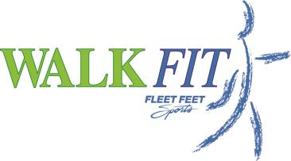

Walk FIT 1 – Beginner
Get WALKING and START YOUR FITNESS PROGRAM!
Spring 2016

Name______________________________________________________
Address____________________________________________________
City ___________________________ State _________
Zip __________________
Contact Phone_________________________________
E-mail_____________________________________________________
Emergency Contact _________________________________________
Emergency Contact phone___________________________________
Gender ______ DOB:__________________________

Shirt Size (unisex sizing): (circle one)
Small Medium Large XLarge XXLarge

Current Fitness Level Required: No current fitness level is required but we do ask that you consult with your doctor prior to starting a fitness program.

REFUND POLICY- Important! If you discontinue this Fleet Feet Sports training program within the first 2 weeks of the class, a full refund will be given. Once you pick up your tech shirt or after first two weeks, you will not be able to request a refund.

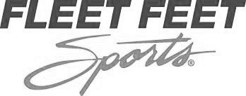

WAIVER AND RELEASE OF LIABILITY -- READ BEFORE SIGNING

In consideration of being allowed to participate in any way in Walk Fit Training Program, its related events and activities, I, the undersigned, acknowledge, appreciate, and agree that:

The risk of injury from the activities involved in this program is significant, and while particular skills, equipment, and personal discipline may reduce this risk, the risk of serious injury or death does exist. I knowingly and freely assume all such risks, both known and unknown, even if arising from the negligence of the releases or others, and assume full responsibility for my participation.

I willingly agree to comply with the stated and customary terms and conditions for participation. If, however, I observe any unusual significant hazard during my presence or participation, I will remove myself from participation and bring such to the attention of the Company immediately. I understand this Fleet Feet Sports location is an independent licensee of Fleet Feet, Incorporated and independently operates this Walk Fit Training Program.

I, for myself and on behalf of my heirs, assigns, personal representatives and next of kin, hereby release, indemnify, and hold harmless FLEET FEET SPORTS Kingsport their agents, employees, coaches, volunteers, officers, directors, franchisors, successors and assigns, the City of Kingsport Tn, and any and all sponsors, their representatives and successors ("Releasees"), with respect to any and all injury, disability, death, or loss or damage to person or property associated with my presence or participation, whether arising from the negligence of the releases or otherwise, to the fullest extent permitted by law.

I attest that I am in good health and physically capable of participating in Walk Fit Training Program, and my medical care provider has approved my participation. Further, I hereby release, consent to, and authorize, in advance, any such use of my name, photograph, voice or likeness by the foregoing parties in any manner they deem appropriate and necessary without remuneration to me.

I HAVE CAREFULLY READ THIS WAIVER AND RELEASE AND FULLY UNDERSTAND ITS CONTENTS.

Signature: __________________________________________________ Date: __________________

Name: _____________________________________________________

FOR PARENTS/GUARDIANS OF PARTICIPANTS OF MINORITY AGE
(UNDER AGE 18 AT TIME OF REGISTRATION)

This is to certify that I, as parent/guardian with legal responsibility for this participant, do consent and agree to his/her release as provided above of all the Releasees, and, for myself, my child and our heirs, assigns, and next of kin, I release and agree to indemnify and hold harmless the Releasees from any and all liabilities incident to my minor child's involvement or participation in these programs as provided above, even if arising from the negligence of the releases, to the fullest extent permitted by law.

Signature of Parent or Legal Guardian: ___________________________ Date: _________________

Name of Parent or Legal Guardian: ______________________________

